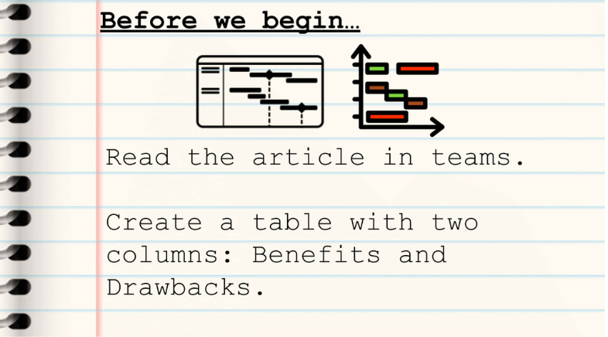
Benefits:
- It Provides a High-Level Overview: A Gantt chart provides an overall perspective of a project and its timeline.
A Gantt chart is visually appealing and easy to understand. It provides critical information about tasks briefly, including the order in which they begin and their duration.
- It Improves Efficiency and Helps Manage Resources: A Gantt chart can help ensure that leaders and workers manage their time and resources effectively.
- It Allows for Better Tracking: A Gantt chart enables project leaders and members to closely track tasks, benchmarks, and overall workflow.
- It Illustrates Overlaps and Dependencies: A Gantt chart clearly communicates how tasks in a project might overlap. It also shows how the beginning of one task can be dependent on the completion of another task.
- It Boosts Productivity: A Gantt chart allows for collaboration among workers to boost their productivity.
- It Allows You to Balance Multiple Projects: A Gantt chart allows managers to easily track multiple projects.
- It Makes Complex Information Manageable: The visual clarity that a Gantt chart provides can help simplify a complex set of tasks.
- It Helps You Set Realistic Deadlines and Expectations: A Gantt chart lays out all the tasks that a team must accomplish to complete a project.
- It Helps Keep Everyone Aligned, Including Remote Workers: When everyone on a project team (including remote workers and those in other offices) has easy access to the same information, all work on the project remains aligned.
- It Motivates Team Members: A Gantt chart enables team members to visualize their tasks, thereby motivating them to do their work on the project.
Drawbacks:
- Setup Can Be Time Consuming: Setting up a Gantt chart for a complex project can be convoluted and time consuming. Software can help.
- They Can Become Complex and Confusing: A Gantt chart for a large project with many tasks and subtasks can become complicated. Adding even more tasks or making changes to the schedule affects the entire chart.
- They Don’t Designate Priorities: Gantt charts focus on presenting the tasks in a project and the approximate time it takes to complete them. The charts don’t show the priority of the tasks you need to complete for the project to be a success
- They Don’t Offer Much Detail Regarding Task Dependencies: Gantt charts can show how you must complete one task before starting another one.
- Task Bars Do Not Show the Amount of Work That Each Task Requires: The length of a Gantt chart task bar shows the amount of time it might take to finish a task.
- Some tasks with short bars (representing short deadlines) might require significant resources. Some tasks with long bars might require minimal resources.

Benefits: | Challenges:
It allows for tracking progress easier. | Task bars do not represent the amount of work needed
Presents a high-level overview of the tasks. | They don’t offer a lot of detail
It helps to let everyone know where they’re at and on track. | Doesn’t offer a lot of detail for tasks.
Helps manage resources. | Can be overwhelming and confusing to read.
Helps to balance tasks. | The setup of one can be time-consuming and tedious.

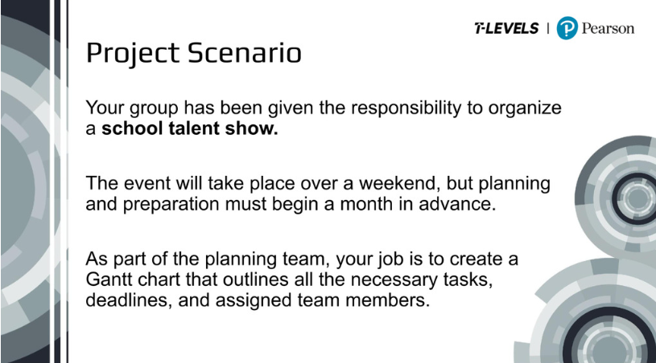
28-day Gantt chart, talent show must take place on last day.
- Advertising for people to go on stage. 7 days ---
- Recruit people to go on stage – Interview process. 14 days ---
- Somewhere for a stage. 3 days
- Somewhere for an audience, rows. 2 days
- Setting up a stage. 2 days
- Getting decorations for stage. 1 day
- Selling tickets, inviting parents, students. 14 days
- Giving each contestant a lot of equipment to perform. 3 days
- Could sell food, baking, drinks. 1 day
- Organise a schedule for people to come on. 2 days
- Someone to introduce the show. 14 days ---
- Keep back first-aid. 3 days ---
- Find judges. 14 days ---
- Ask the school for money. 1 day.
- Rehearsals before the actual show. 1 day.
Logical order:
14, 1, 3, 6, 5, 4, 8, 2, 7-11-13-12, 9, 15, 10.
Dependencies:
All depend on 14.
2, 11, 13 depends on 1
5, 4, 6 depends on 3
All depend on 2 as well, if not a lot of people, talent show won’t benefit the school.
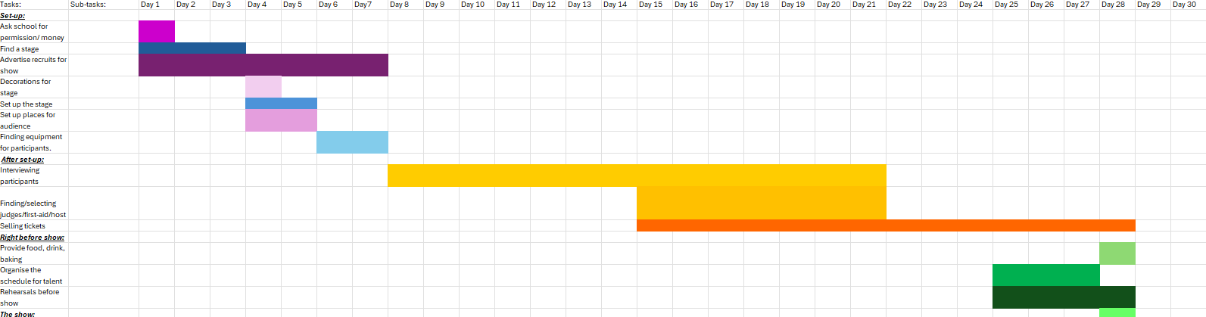
NEW EHR SYSTEM.
